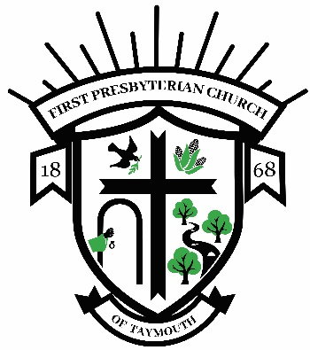

First Presbyterian Church of Taymouth
The Rev. J. Scott Kroener, Pastor

March 1, 2022

Dear Applicant,

We thank you for taking the time and interest to apply for the Muriel Lakey Memorial Scholarship. The attached scholarship application is designed to help us determine who is suited to receive a grant and to make sure that the qualifications of the scholarship have been met. Please fill out the application in its entirety and return it to the church office by the March 31st deadline.
Muriel Lakey was the wife of Rev. Robert Lakey, pastor of this church from 1952-1957 and pastor of Saginaw Second Presbyterian Church for 35 years after that. His wife served as a missionary to India where she spent much of her time and effort as a teacher helping young people. In recognition of her dedication to education and her love of young people, this scholarship was established in her memory. Each year all of the interest earned by the financial principal of the scholarship fund must be given away to the person or persons applying.
Anyone pursuing post-high school education is welcome to apply as long as the following three criteria are met:
1. Member of the First Presbyterian Church of Taymouth
2. Financial need
3. Involvement in the life of the church.

These are the conditions that the donor requested and the Session agreed to when this scholarship was created in 1997.
While we would love to be able to give every applicant a scholarship, this is not always possible. However, each year at least one scholarship must be awarded. The Session, or its designated representative(s), decides whether to split the available scholarship funds or designate to one applicant. All factors being equal, higher consideration will be given to those who have not previously received a scholarship.
The decision of the Session, or its designated representative(s), is final. If you have any questions, please ask. Thank you for applying and may you find God’s blessings in whatever education you seek.

Yours in Christ,

The Rev. Scott Kroener, Pastor

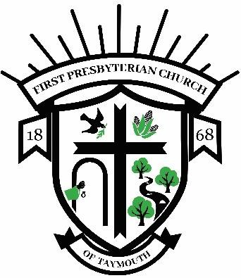
First Presbyterian Church of Taymouth
The Rev. J. Scott Kroener, Pastor

THE MURIEL LAKEY SCHOLARSHIP

Application Deadline: March 31st, 2022

Applicant Name: ___________________________________________ Phone: __________________

Mailing Address: ______________________________________________________________________

Years of Church Membership: _______________________ Year of Schooling: __________________

School You Plan to Attend: ____________________________________________________________

Education / Training the Scholarship would be used for: _____________________________________

Please answer the following questions as fully as possible:

- Please describe the ways you have or are participating in the life of Taymouth Presbyterian Church. This can include work you do for the church, groups you take part in, events or tasks you help with, attendance in worship, or any other information about you and your life within the church. If you are a newer member of the church or currently away at school, you may include activities at another church. (If you need more space you can use an extra sheet of paper.)

- Please describe the ways in which your education will further your goals in life. (If you need more space you can use an extra sheet of paper.)

Applicant Signature: ___________________________________________ Date: ______________

